MUSICAL PLAYLIST MANAGER

Introduction

The Musical Playlist Management System using a Doubly Linked List in C++ is a project designed to manage songs in a playlist efficiently. A doubly linked list is a linear data structure in which each node contains song information and two pointers: one pointing to the previous node and another pointing to the next node. This structure allows users to move forward and backward through the playlist easily.The system provides various operations such as adding a song, deleting a song, searching for a song, displaying the playlist, playing the next song, and playing the previous song. It uses the concepts of data structures, pointers, dynamic memory allocation, and menu-driven programming in C++. This project demonstrates how doubly linked lists can be used in real-world applications for efficient playlist management.

Problem Statement
Implement a menu-driven Musical Playlist Manager in C++ using a Doubly Linked List. Each song must store its title, artist, and album. The application should allow the user to add, display, search, delete, and reverse songs, navigate to the next and previous songs, play the currently selected song (display its details), and clear the playlist. The program should handle an empty playlist and maintain the links correctly after insertions and deletions.

Objectives
- Understand the structure and operation of a Doubly Linked List.
- Store each song's title, artist, and album in a dynamically allocated node.
- Implement insertion at the end of the playlist and display all songs.
- Support forward and backward navigation through next and prev pointers.
- Search for and delete a song by its title.
- Reverse the playlist by swapping each node's prev and next pointers.
- Clear the playlist and release dynamically allocated memory.
- Practice menu-driven programming, pointer manipulation, and linked-list traversal.

Data Structure Used
A Doubly Linked List is a collection of nodes where each node points to both the previous and the next node. In this project, a Song node contains title, artist, album, prev, and next. The Playlist class maintains head (first song), tail (last song), and current (selected song). This supports movement in both directions.

Algorithm

Initialize
- Set head, tail, and current to NULL.
- Display the menu and read the user's choice.

Add Song
- Read title, artist, and album; create a new node.
- If empty, set head, tail, and current to the new node.
- Otherwise link the new node after tail and update tail.

Display Playlist
- If head is NULL, report an empty playlist.
- Otherwise traverse from head using next and print every song.

Play Current / Next / Previous
- If current is NULL, report an empty playlist.
- For Next, move current to current->next if it exists.
- For Previous, move current to current->prev if it exists.
- Display the selected song details.

Search Song
- Read a title and traverse from head.
- If a matching title is found, display its details; otherwise report not found.

Delete Song
- Find the node with the requested title.
- Reconnect neighbouring nodes and update head or tail when necessary.
- If current is deleted, select the next node if available, otherwise the previous node.
- Delete the node.

Reverse Playlist
- For every node, swap prev and next.
- Swap head and tail.

Clear Playlist
- Traverse the list and delete every node, saving next before deletion.
- Set head, tail, and current to NULL.

Exit
- Repeat until the user enters 0.
- The destructor releases any remaining nodes.

Flowchart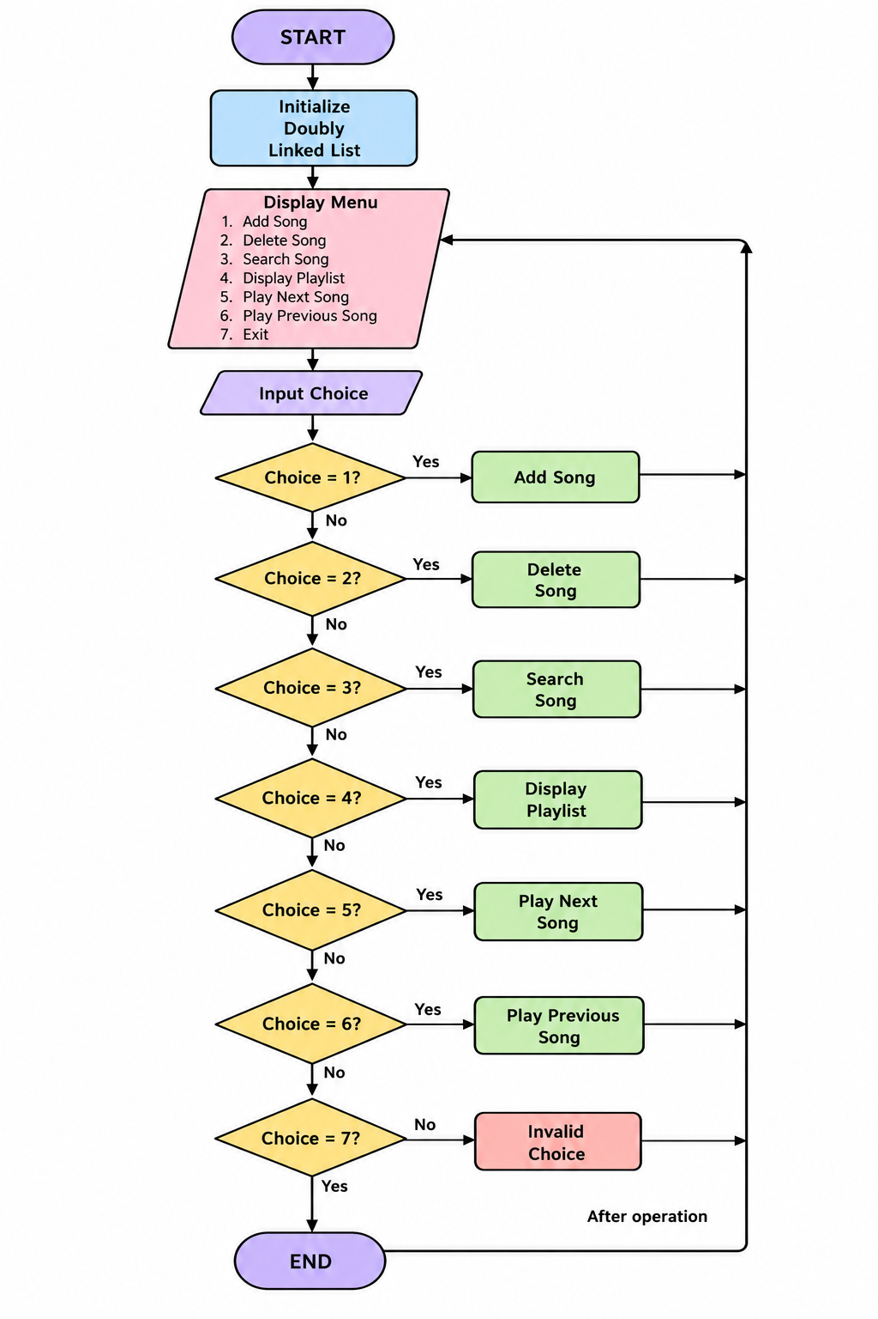

Conclusion:-

The Musical Playlist Management System successfully demonstrates the practical implementation of a doubly linked list using C++. It allows users to perform essential playlist operations, including insertion, deletion, searching, and forward and backward navigation. The project helps in understanding dynamic memory allocation, pointers, and linked list operations.Thus, the project provides a simple and efficient way to manage a musical playlist while improving knowledge of data structures and problem-solving techniques. In the future, the system can be enhanced by adding features such as song duration, shuffle play, repeat mode, and integration with audio playback functionality.

